**Project Design Phase**

**Solution Architecture**

|  |  |
| --- | --- |
| Date | 22 June 2025 |
| Team ID | LTVIP2025TMID58635 |
| Project Name | ShopSmart - eCommerce Grocery Web app |
| Maximum Marks | 4 Marks |

**Solution Architecture:**

The technical architecture of an flower and gift delivery app typically involves a client-server model, where the frontend represents the client and the backend serves as the server. The frontend is responsible for user interface, interaction, and presentation, while the backend handles data storage, business logic, and integration with external services like payment gateways and databases. Communication between the frontend and backend is typically facilitated through APIs, enabling seamless data exchange and functionality.

**Solution Architecture Diagram:**

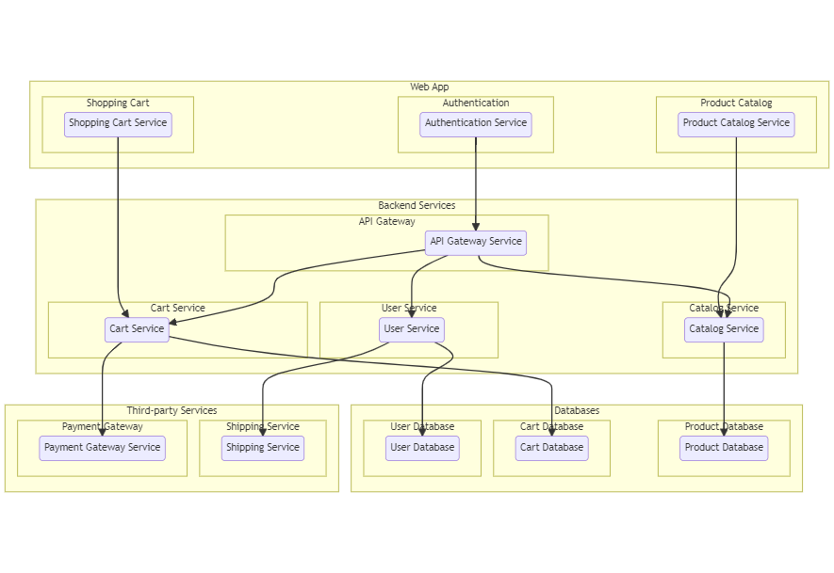

**ER Diagram:**

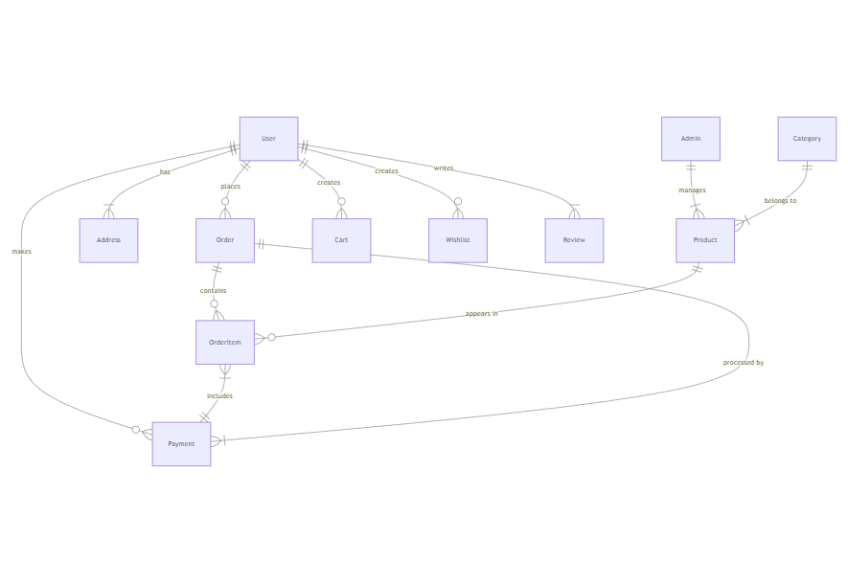

The Entity-Relationship (ER) diagram for an flower and gift delivery app visually represents the relationships between different entities involved in the system, such as users, products, orders, and reviews. It illustrates how these entities are related to each other and helps in understanding the overall database structure and data flow within the application.